Valentines Facebook/Instagram Post Ideas
KathytheCopywriter.com

[Deer hunting facebook/Instagram Ideas]

[Hashtag ideas]
#ratherbehunting
#fortheloveofhunting
#huntingLove

Option #1:
Image: Heart-shaped antlers

Embedded copy inside image:
I love you more than anything
(now that hunting season is over)

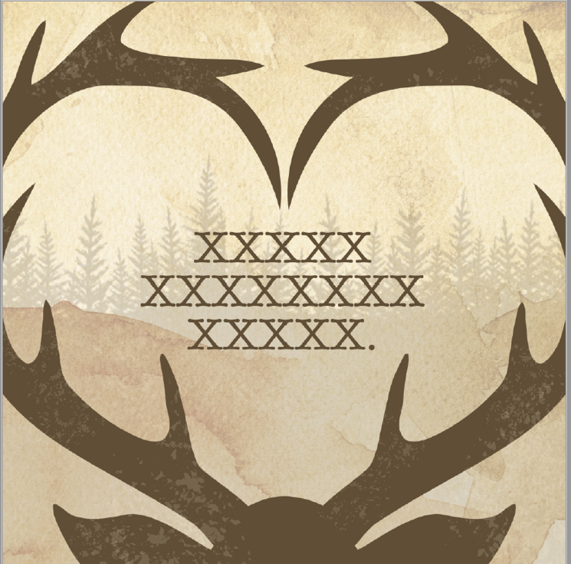

Post Copy: Now that whitetail season is over, turn your focus from that fantasy 14-point buck to the real "dear" in your life. Happy Valentine's Day Hunters!
#ratherbehunting

Option #2:
Image: Heart-shaped antlers

Embedded copy inside image:
You're My #1 Love
(now that hunting season is over)
Post Copy: Now that whitetail opener is over, focus on what you really love! Happy Valentine's Day hunters!
Option #3:
Image: Heart-shaped antlers

Embedded copy inside image: Nice rack!
Post copy: It's the one time of year you can get away with saying this. Happy Valentine's Day hunters—and the "dear" who love them!
#ratherbehunting
#fortheloveofhunting
#huntingLove

Option #4:
Image: Heart-shaped antlers
Embedded copy inside image: I'd rather be hunting.
Post copy: We get it. You'd rather be whitetail hunting right now. But since the season's over, it's time to focus on your second love. Happy Valentine's Day hunters—and the wives who love them!

[Fishing Post Ideas]

Hashtag Ideas:
#ratherbefishing
#fortheloveoffishing
#fishingLove
#gonefishing
#lifeisbetteronthelake
#wishingIwasFishing

Option #1:
Image: Fish Biting Hook
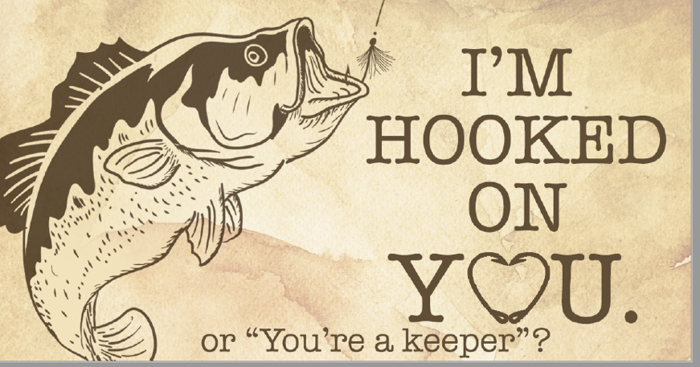
Embedded copy inside image: World's Greatest Catch
Post copy: This Valentine's day, tell your significant other how much you love them.
#fishingLove

Option #2:
Image: Fish Biting Hook
Image Embedded copy: You're A Keeper
Post copy: I've caught and released my share of fish, but you're a catch I never want to let go of.
Happy Valentine's Day fishermen and women!

Option #3:
Image: Fish Biting Hook
Image Embedded copy: I'd rather be fishing. But not without you.
Post copy: This Valentine's Day, tell your significant other how much you love them. Share this post with the love of your life.

Option #4:
Image: Fish Biting Hook
Image Embedded copy: Catch of the Day.
Post copy: "When I tell my buddies about you, they think I’m telling them fish stories, but you're the reel deal." Happy Valentine's Day fishermen—and the women who love them!
Option #5:
Image: Fish Biting Hook
Image Embedded copy: You've captured me in a big way.
Post copy: "Lures. Baits. Attractants. However I got you, I'm thankful you got in my boat."
Happy Valentine's Day fishermen—and the women who love them!

Option #6:
Image: Fish Biting Hook
Image Embedded copy: The catch of a lifetime
Post copy: "I've caught everything from giant catfish to trophy musky, but the best catch I've ever had is sinking you." Happy Valentine's Day fishermen—and the women who love them!

Option #7:
Image: Fish Biting Hook
Image Embedded copy: CARP-e-diem
Post copy: There's no better time like the present. Today, take your loved ones fishing. Happy Valentines Day fishing enthusiasts!

[Shooting Sports ideas]

[Hashtag ideas]
#shootingenthusiast
#rangetime
#shootingsportsLove
#lovetherange
#rangetime
#RangeDay

Option #1:
Image: Guns and ammo
Embedded copy inside image: We go together like guns and ammo (as is)

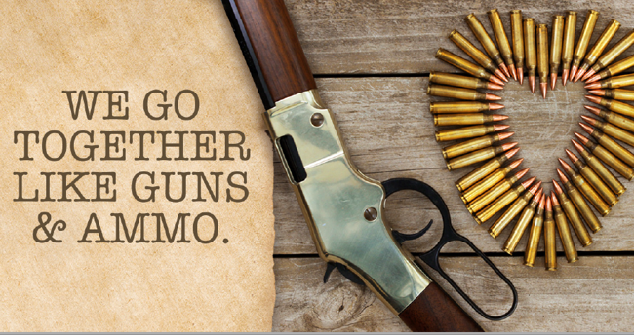
Post copy: Happy Valentine's Day shooting sports enthusiasts!

Option #2:
Image: Guns and ammo
Embedded copy inside image: You're my perfect match.
Post copy: Love is in the air. Or is it the smell of gun powder? Either way, it's the perfect day for a range date! Happy Valentine's day shooting sports enthusiasts.
#lovetherange

Option #3:
Image: Guns and ammo
Embedded copy inside image: Today's fortune: give it your best shot.
Post copy: Looking to ignite that rapid-fire romance? This Valentine's day, ask her on a date to the shooting range.

Option #3:
Image: Guns and ammo
Embedded copy inside image: Today's fortune: give it your best shot.
This Valentine's day, turn your range day into a range date! Ask her out for a first date she'll never forget.
[alt option for women audience] This Valentine's day, turn your range day into a range date! Ask him out for a first date he'll never forget.
#rangedate

